The list of shops where you can use gift card in Bory Mall from **2.10.2024**

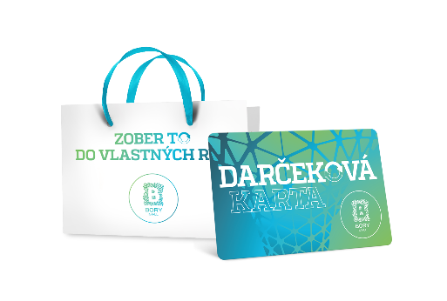

1. ALAIN DELON
2. ALBI
3. ALDO
4. ALLTOYS
5. ALPINE PRO
6. ASIAN SHOP
7. ATTRACTIV
8. AUTOŠKÔLKA
9. BAGETERIE BOULEVARD
10. BEPON
11. BILLA
12. BIOTECH USA
13. BJÖRN BORG
14. BLE BLE
15. BLESK ČISTIAREŇ
16. BLISK
17. BOWLICHECK
18. BRLOH
19. BUPPI
20. BURGER KING
21. C&A
22. CALZEDONIA
23. CCC
24. CEWE FOTOLAB
25. CILEK
26. CINEMAX
27. CRAFT COFFEE
28. CROPP
29. CURAPROX
30. ČEDOK
31. D´FASHION
32. DATES MOBILE
33. DEICHMANN
34. DELIKATESO
35. DH STORE
36. DIVOKÁ KAČKA
37. DM DROGERIE MARKT
38. DORMEO HOME
39. DOUBLE RED
40. DOUGLAS
41. DR. MAX I., II.
42. DRÁČIK
43. ECCO
44. EDO-KIN
45. ENDORPHIN REPUBLIC
46. ERRORE
47. ETA
48. FANN PARFUMÉRIE
49. FAX COPY
50. FIXSERVIS
51. FRESH BBQ
52. FRESH GRILL & SALAD
53. FRUITISIMO
54. GANT
55. GOLD BARBERSHOP
56. GOLD POINT
57. GOLEM CLUB
58. GRANDOPTICAL
59. HACHI HACHI
60. H&M, H&M HOME
61. HELLY HANSEN
62. HOUSE
63. HUMANIC
64. HYDROTOUR
65. CHUCK&FRIDA (REGAL BURGER, POKE BISTRO, EATBALLZ)
66. INTERSPORT
67. INTIMISSIMI
68. iSTYLE
69. IQOS
70. JOLLEO
71. JULIUS MEINL
72. KARA
73. KFC
74. KLIER
75. KNIP
76. KOLIBA
77. KUBU
78. LARA BAGS
79. LARA BEAUTY
80. LINDEX
81. LOS CAPOLITOS
82. LOTSI
83. MANUFAKTURA
84. MARREA
85. MATERASSO
86. MCDONALD'S
87. MEATFLY
88. MEDIAPRESS TRAFIKA I., II.
89. MICHELL
90. MI STORE
91. MOBILE OUTFITTERS
92. MOHITO
93. MONDIEU
94. MULTICOOK
95. MUZIKER
96. NATACHA PACAL PATISSERIE
97. NATURHOUSE
98. NAY
99. NEKONEČNO
100. NOODLES BY YAN
101. NOSENE
102. O2
103. OFFICE SHOES
104. OPTIKA FRÖHLICH
105. OPTIKA MANIA
106. ORANGE
107. ORION
108. ORSAY
109. OXALIS
110. OZETA
111. PANTA RHEI
112. PARTYLAND
113. PEDRO
114. PEKÁREŇ LIPÓT
115. PHO
116. PIZZA HUT
117. POHODLIE PHASE
118. PRESPÁNOK
119. PRIMROSE
120. PUPA
121. REGATTA
122. RESERVED
123. RHAPIS
124. RITUALS
125. s.OLIVER
126. SAMSONITE
127. SAMSUNG
128. SATYAM
129. SCAN QUILT
130. SINSAY
131. SOFIA
132. SPORTISIMO
133. SPORTS DIRECT
134. SPORT VISION
135. STARBUCKS
136. STARÝ OTEC
137. SUPER ZOO
138. ŠEVT
139. TAKKO FASHION
140. TEDI
141. TERRANOVA
142. TESCOMA
143. TEZENIS
144. TETA DROGÉRIA
145. TCHIBO
146. TIME OUT DETSKÝ KÚTIK
147. TITI PAPIERNICTVO
148. TOP FUN
149. TRAPPER
150. TRDLOKAFE
151. TUI REISECENTER
152. TURKISH FOODS
153. UNDER ARMOUR
154. VIAHE
155. VNÍMAVÉ DETI
156. YAKUZA
157. YVES ROCHER
158. WINE PLANET
159. WOMAN´S